Long Term Overview: The Reading Journey for Year 1 2021-2022 Non-Fiction Fiction Poetry Author focus
Autumn 1 | Autumn 2 | Spring 1 | Spring 2 | Summer 1 | Summer 2
Reading Journey 1 | Reading Journey 1 | Reading Journey 1 | Reading Journey 1 | Reading Journey 1 | Reading Journey 1
Space-linked to ‘Infinity and Beyond’ topic.  Narrative -Vocab/Inference/Sequence  Linked to our topic.  VIPERS.  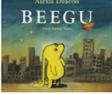  Narrative  Mae-Jemison-First Black Woman in Space.  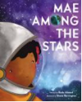  Non-Fiction. The Planets-Retrieve  .  VIPERS  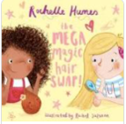  PSHE-Being yourself. Different hair types.  Poetry: retrieve and visualise information in the text. Space poems-Blast off | Sounds and Feelings-Bang, Crackle and Whoosh topic.  Narrative: Story sequencing retrieve, infer, vocab *  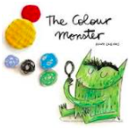  Anti-Bullying, PSHE, Feelings, Self-regulation.  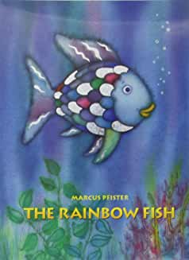  Non-chronological -Celebrating other cultures.  Poetry: retrieve and visualise information in the text. *  VIPERS  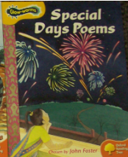 | Geography: Our Adventure-Once upon a Journey  Narrative:  Queens hat  VIPERS  Knowledge of landmarks.  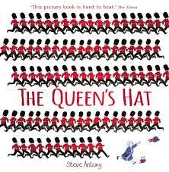  Information text-London  VIPERS  Poetry: retrieve information from a text, draw upon knowledge of vocabulary to understand the text. *  VIPERS  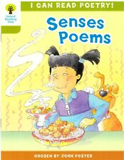  Magic London Bus poem  VIPERS | Once upon a journey  Powerful vocabulary – settings.tt  VIPERS  My names is not refugee  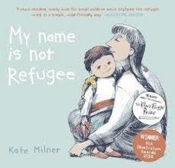  Narrative: sequence the events in a story, retrieve information from the text. *  Classic Text  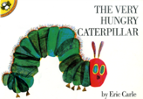  VIPERS  Poetry-Shopping List  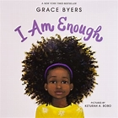 | Animals  Narrative  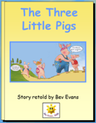  Traditional Tale  Key story language  VIPERS  Narrative  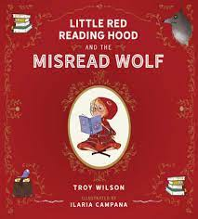  Twisted Fairytale.  Importance of storytime at home and in school.  Narrative  VIPERS  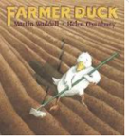  Non-fiction: Information Texts. Animal Farm/Farm yards.  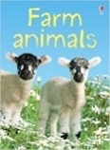  Victorian 60 Second read  Poetry-Down on the Farm | Author Focus  Rhyming  Narrative. Julia Donaldson  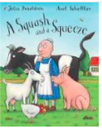  Narrative: make predictions about what a character will do and say, infer info. Julia Donaldson  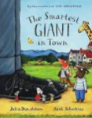  Non fiction-Instructions. How to grow a plant.  Poetry-Shuffle and Squelch. Julia Donaldson

